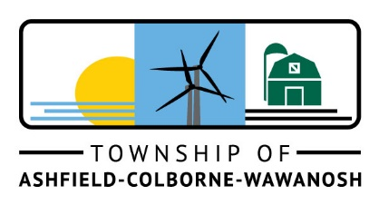
SUMMER STUDENT OPPORTUNITIES!
The Township of Ashfield-Colborne-Wawanosh is seeking responsible and motivated students to join our team for the spring/summer season. This is a great opportunity to gain valuable experience in the public sector while contributing to the community.
Public Works Summer Student (2)
Office Administration Summer Student (2)

To be eligible for a student position with the Township of Ashfield-Colborne-Wawanosh, you must be:
- Currently enrolled in full-time post-secondary studies, or plan to attend post-secondary education in the fall of 2023;
- Returning to full-time studies in the fall of 2023;
- Available to work full-time between May and August;
- 16 to 30 years of age, with a valid Ontario Driver’s License (minimum G2).

To learn more about these job opportunities, visit www.acwtownship.ca/government/careers .
Applications will be received in confidence by the undersigned until
12:00 p.m. February 17, 2023

Mark Becker, CAO
82133 Council Line, RR 5
Goderich, ON N7A 3Y2
cao@acwtownship.ca
www.acwtownship.ca

We thank all applicants who apply for the position; however only those selected for an interview will be contacted. Personal information is collected in accordance with the Municipal Freedom of Information and Protection of Privacy Act and will be used only for employment purposes.

